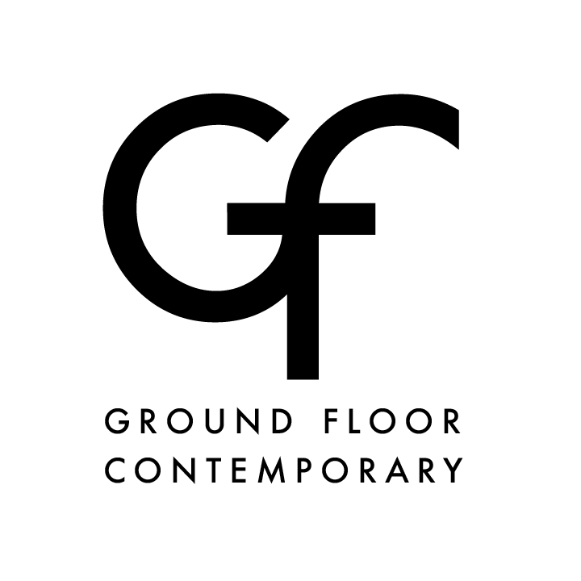

Ground Floor Contemporary is pleased to present Through the Lens, an exhibition of new works by member artists Anita Gomez-Ronderos, Claire LeSar, and Jimmy Nunn Jr. The artists pursue their personal perspectives on the world around them and its effect on their individual lives.

Join us for the Opening Reception on Thursday, March 7 from 5 – 7:30 pm.

The gallery is open on the following Sundays, Mar. 10, 17, 24 from 1:00 pm to 4:00 pm and will include the following event:
March 10 2 pm Artist talks
March 24 2 pm Screen printing workshop – go home with a print!

Claire LeSar’s work celebrates the reality that, though we may be different, we are all tied together in the sameness of humanity.

Jimmy Nunn Jr. presents fabricated abstractions of brown skin that manufacture a mercurial moment for the viewer’s mind. Fluctuating between flat and dimensional, overlapping layers and clarity of form animate their process of becoming.

Anita Gomez-Ronderos creates personal observations of nature combining watercolor and hand-made paper contrasted with needlework.

Ground Floor Contemporary is a cooperative art gallery committed to promoting and expanding
the visual arts scene in the greater Birmingham area. The gallery space is open to the public
from 1pm to 4pm on Sundays and by appointment. It is located at
111 Richard Arrington Jr. Blvd S, Birmingham, AL 35233.
Please visit http://groundfloorcontemporary.com for more information.

