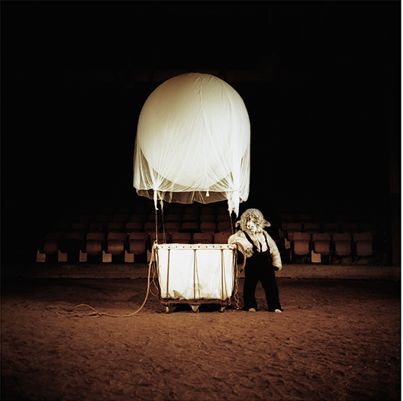
FOR IMMEDIATE RELEASE

Menagerie: ANIMAL AS SYMBOL

Contact: Ground Floor Contemporary
Daisie Hoitsma,
Gallery Manager
903-641-6209
daisiehoitsma@gmail.com

Image: Jenny Fine with the Wellington School,
Maybe the cows, but not the sheep; 2012

Ground Floor Contemporary is pleased to present Menagerie: Animal as Symbol curated by Stacey Holloway opening July 13, 2017. This exhibition explores the use of animal symbolism within visual art and features a collection of national and local artists working in a variety of media.

The form of the narrative has been used for centuries to entertain, to preserve culture and to instill morals. Stories can be used to bridge cultures, languages and age barriers. With such storytellers like Aesop, our narratives often begin with the animal realm and using specific animal attributes to explore how our emotions, our morals, and our relationships intersect.

Stacey Holloway is an active national installation-based artist and Assistant Professor of Sculpture at UAB Department of Art and Art History. Through her artwork she explores storytelling and ethology and constructs sculptural stills that represent anxieties and fears that collide with
a world of ambiguous sub consciousness.

Menagerie: ANIMAL AS SYMBOL opens Thursday, July 13, from 5pm to 7:30 pm, and will also be open the following three Sundays. Sunday gallery hours are from 1pm to 4pm and will include
talks and conversations by the following:
July 13, 5 – 7:30 pm Gallery opening
July 16, 2 pm: Talk by UAB Art History Professor Jessica Dallow, Ph.D
July 23, 2 pm: Curator’s talk
July 30, 2 pm: Talk and animal visits by Ruffner Mountain Nature Preserve

Thirty percent of art sales along with contributions received will benefit Ruffner Mountain,
a 1,038-acre urban nature preserve located in Birmingham, AL.

Ground Floor Contemporary is a contemporary art gallery providing exhibition opportunities
for its member artists, and committed to promoting and expanding the visual arts scene in the greater Birmingham area. The gallery space is open to the public from 1pm to 4pm on Sundays and by appointment. It is located at 111 Richard Arrington Blvd S, Birmingham, AL 35233. Please visit http://groundfloorcontemporary.com/ for more information.

Participating artists:

Lesley Baker, Indianapolis, IN
Doug Baulos, Birmingham, AL
Kristen Berry, Montevallo, AL
Rachel Bleil, Indianapolis, IN
Page Burch, Atlanta, GA
Merrilee Challiss, Birmingham, AL
Gary Chapman, Birmingham, AL
Derek Cracco, Birmingham, AL
Andrew Perry Davis, Indianapolis, IN
Lee Deigaard, New Orleans, LA
Cat Duncan, Birmingham, AL
Alyssa Fagaly, Birmingham, AL
Jenny Fine, Enterprise, AL
Nelson Grice, Birmingham, AL
Sarah Heath, Birmingham, AL
Heather Spencer Holmes, Birmingham, AL
Bonard Hughins, Birmingham, AL
Keith Kaziak, Wausau, WI
Lauren Kinney, Nashville, TN
Janice Kluge, Birmingham, AL

Mumu Lasseter, Birmingham, AL
Katelyn Ledford, Providence, RI
Devin Lunsford, Birmingham, AL
Bryce Martinez, Birmingham, AL
Stacy Morgan, Huntsville, AL
Aaron Leif Nicholson, Muncie, IN
Cary Norton, Birmingham, AL
Allen Peterson, Atlanta, GA
Celeste Amparo Pfau, Birmingham, AL
Jacob Phillips, Dothan, AL
Wayne Potratz, Minneapolis, MN
Jared Ragland, Birmingham, AL
Chiharu Roach, Birmingham, AL
Savannah Smith, Montevallo, AL
Annie Strong, Birmingham, AL
Katie Thompson, Birmingham, AL
Patrick Vincent, Nashville, TN
Ajene Williams, Birmingham, AL
Jon Skyler Woolley, Birmingham, AL
Rachel Wright, Mobile, AL
Tony Wright, Mobile, AL

